Sumama Rahim
F24BSCS039
Database systems Lab 04 Task Report

Name | Sumama Rahim | Course | Database Systems (CSC-103) | Dprtt/ Program | IET - BSCS
Registration | F24BSCS039 | Instructor | Dr. M. Bilal Shahnawaz | Date | 03/30/2025

Lab 04 Task Report

Problem: Write a report to show the applied queries and their responses.

Solution:
Query 1. Show all of the Employees whose name start with Z and live in Islamabad.
-- 1. Show all of the Employees whose name start with Z and live in Islamabad --
SELECT *
FROM Employee
WHERE Employee_Name LIKE 'Z%'
AND City = 'Islamabad';
Response:

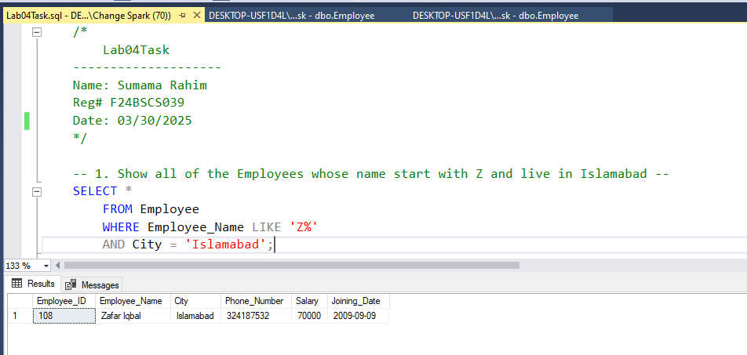

Query 2. Show all of the Employee who have salary more than 50k and live in Rawalpindi but their name must start with A.
-- 2. Show all of the Employees who have a salary more than 50k and live in Rawalpindi but their name must start with A
SELECT *
FROM Employee
WHERE (Salary > 50000 AND City = 'Rawalpindi')
AND Employee_Name LIKE 'A%';
Response:
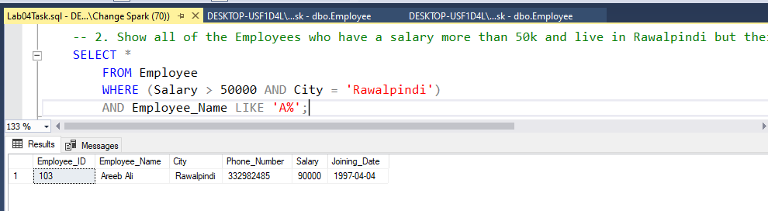

Query 3. Show all of the Employees who live in Islamabad and Rawalpindi and Earn more than 90k.
-- 3. Show all of the Employees who live in Islamabad and Rawalpindi and Earn more than 90k --
SELECT *
FROM Employee
WHERE (City = 'Islamabad' OR City = 'Rawalpindi')
AND Salary > 90000;

Response:
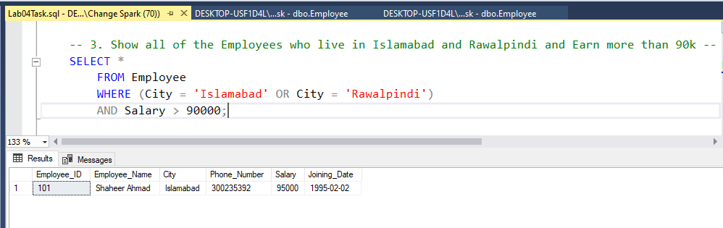

Query 4. Show all of the Employees starting their name with A, who live in Islamabad and Rawalpindi and earn 90k.
-- 4. Show all of the Employees starting their name with A, who live in Islamabad, Rawalpindi and earn 90k -
SELECT *
FROM Employee
WHERE (City = 'Islamabad' OR City = 'Rawalpindi')
AND Employee_Name LIKE 'A%' AND Salary = 90000;
Response:
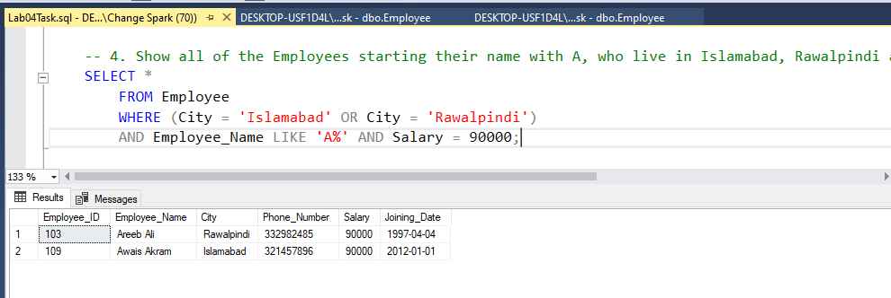

Query 5. Show top 4 employees from the table.
-- 5. Show top 4 Employees from the table --
SELECT TOP 4 *
FROM Employee;
Response:

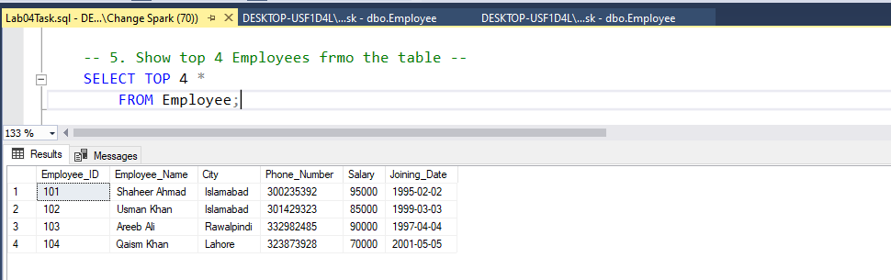

Query 6. Show name of Employee who is earning more than 90k.
-- 6. Show name of Employee who is earning more than 90k --
SELECT Employee_Name
FROM Employee
WHERE Salary > 90000;
Response:

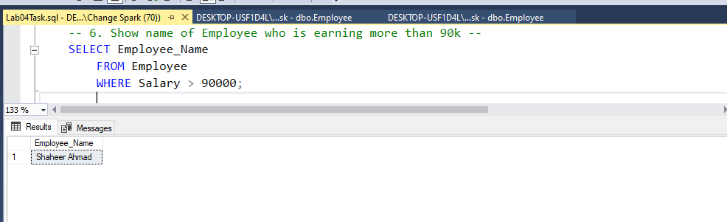

Query 7. Show first three employees is descending order whose name starts with A.
-- 7. Show first three employees in descending order whose name starts with A --
SELECT TOP 3 *
FROM Employee
WHERE Employee_Name LIKE 'A%'
ORDER BY Employee_Name DESC;

Response:

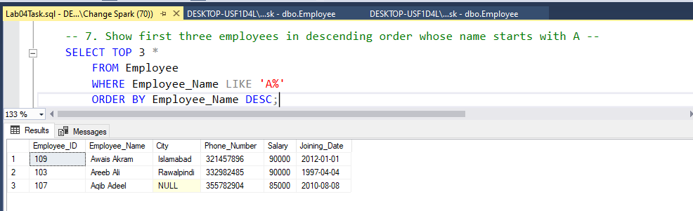

Query 8. Show three junior Employees along with EmployeeID and Joining date.
-- 8. Show three junior Employees along with Employee_ID and Joining Date --
SELECT TOP 3 Employee_ID, Joining_Date
FROM Employee
ORDER BY Joining_Date DESC;
Response:

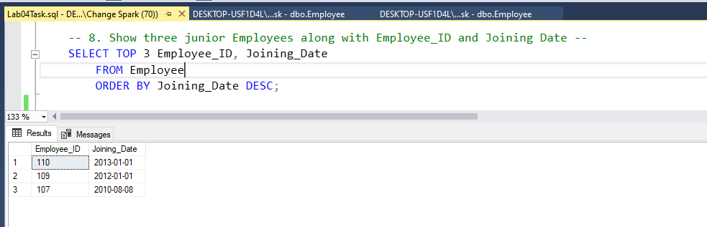
Query 9. Show all of the Employees with their salary, on the basis of seniority.
-- 9. Show all of the Employees with their Salary, on the basis of seniority --
SELECT *
FROM Employee
ORDER BY Joining_Date ASC;
Response:

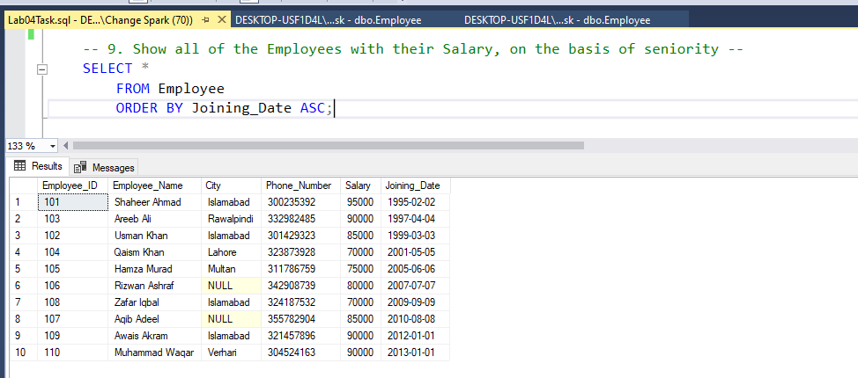

Query 10. If 30% increment is given, what will be the new salary of 3 senior employees.
-- 10. If 30% increment is given, what will be new salary of 3 senior employee --
SELECT TOP 3 *, Salary+Salary*0.30 AS "New_Salary"
FROM Employee
ORDER BY Joining_Date ASC;
Response:

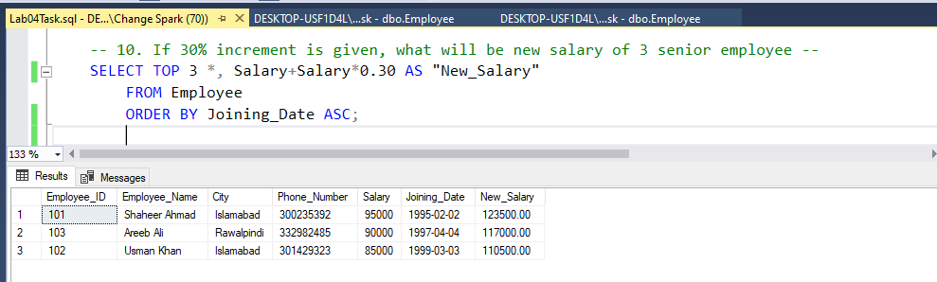

THE END

